

|  |
| --- |
| [Version 1.0]  **Last saved by: Charlotte Hutchinson**  **Last saved on:** 19/1/2015 |

|  |
| --- |
| Iteration 7 Plan |
| [Publish Date] |
| **Charlotte Hutchinson**  CO600: JustHealth Supervisor: Yang He |

JustHealth Iteration 7 Plan

Based on our user feedback for JustHealth Release 1 it has become noticeable that the design for both the website and the android app need improving. Therefore we have decided to create a whole iteration for working on the design.

We will not create any new test cases for this iteration. However, we will run all the functionality tests again for both web and android to check that the changes do not break any functionality.

# Aims:

* A consistent design
* Implemented stronger and more professional design
* Validation on all aspects
* Feedback to the user

# Requirements:

## 2.1 Functional requirements:

* The app works as it is meant to
* All already implemented functionality works correctly
* Improve navigation

## 2.2 Non-functional requirements:

* Speed
* Performance
* Consistency
* Reliability
* Robustness

## 2.3 Domain Requirements:

* Compatible with colour blindness

# Website Design

For the website we have decided to make a more professional look, by creating a dashboard for the home page to replace the tiles and have a list of navigation options either across the top or down the side. We are also going to use more modals to create a smoother user experience.

As a result of feedback post the first release of JustHealth, we have decided the application is in need of re-design. This is to improve the user interaction with the application and to make it more professional.

Each of the pages have been wire-framed again to give us an idea of the new appearance, this will help us to envision what we are working to produce in regards to design.

## 3.1 Log in

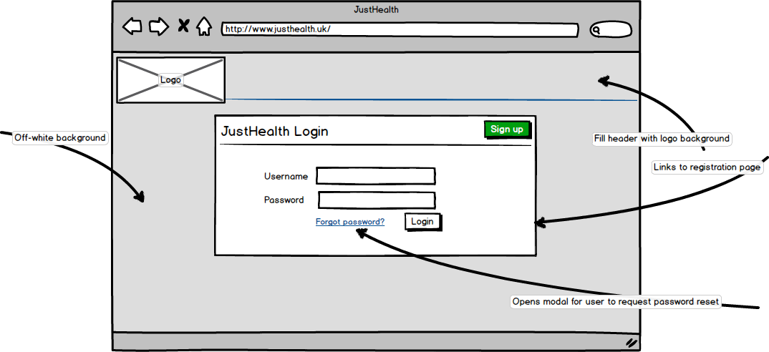

The primary changes to the user log in page are creating a more professional first impression of the application. We will also make navigation to the registration page more obvious to the user.

## webregistration23.2 Registration

This page is now clearer to the user, some of the feedback we received was that users would not enter data into an application that didn’t look professional, official or of industry standard.

## C:\Users\benmcg92\AppData\Local\Microsoft\Windows\INetCache\Content.Word\webhome2.png3.3 Home page (Dashboard style)

Due to user feedback, we have decided to restructure the navigation of the web application. The tile layout will now be limited to the android application for ease of use, and will be replaced by a dashboard on the web.

The dashboard will incorporate relevant content to the user, depending on account type. From this page, the user will be able to navigate the application easily.

## 3.4 Appointments pages

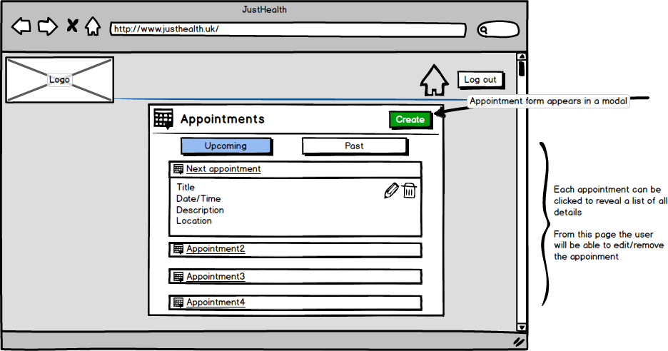

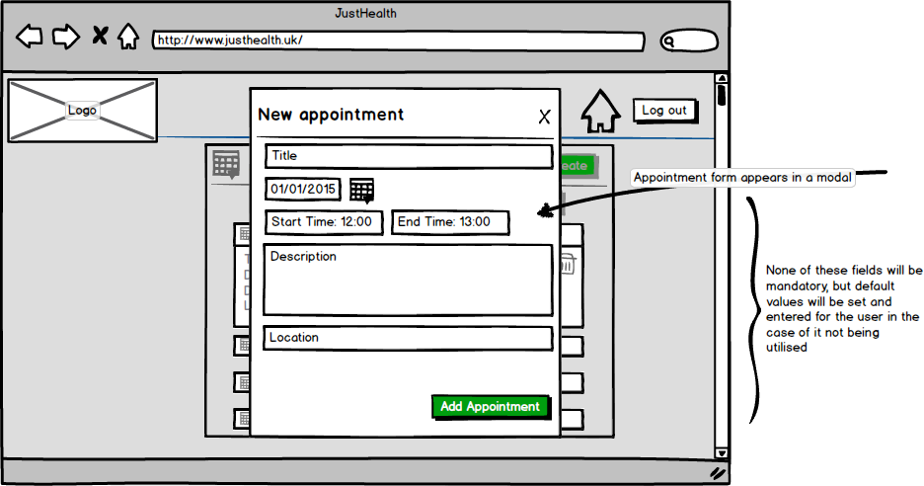Appointments will be reorganised and reordered so the navigation is more user friendly. The main update to this page will be the form to create a new appointment will now open in a modal.

## 3.5 Connections

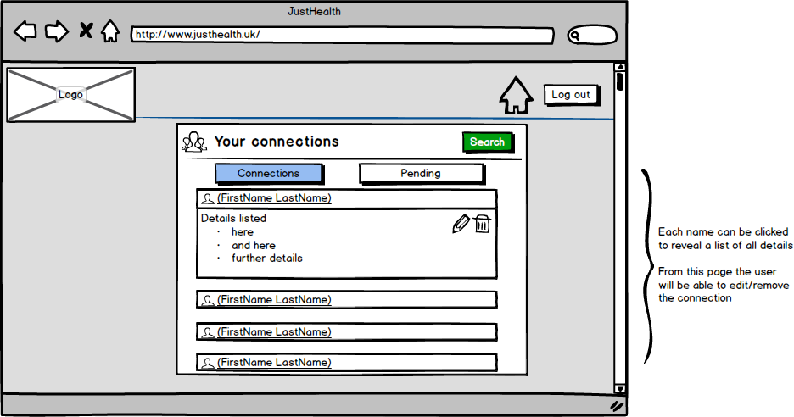

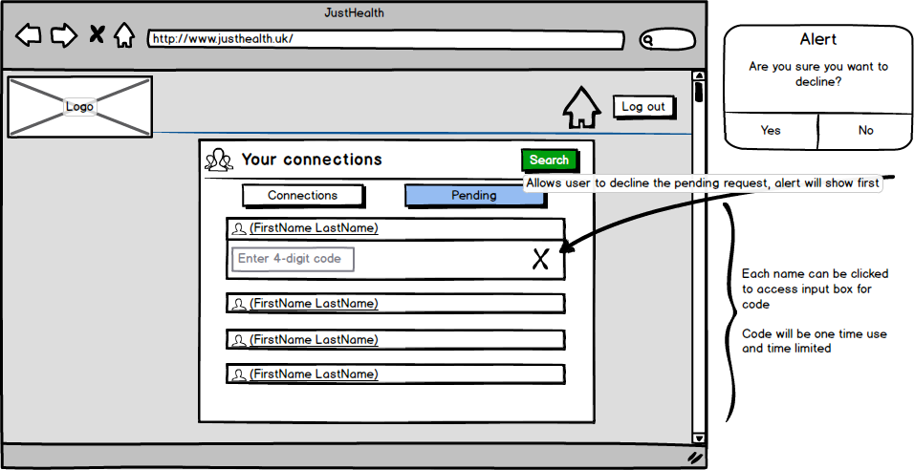Similarly with connections, the pages are clearer, navigation is simpler and the overall feel is more professional.

## 3.6 Settings pages

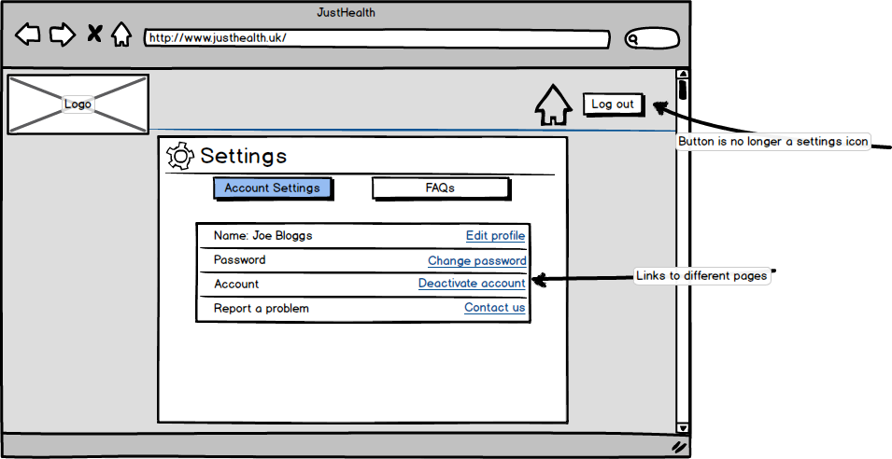User settings pages will be changed dramatically, the main aims being:

* Keep everything accessible from one location
* Prioritise ease of use
* 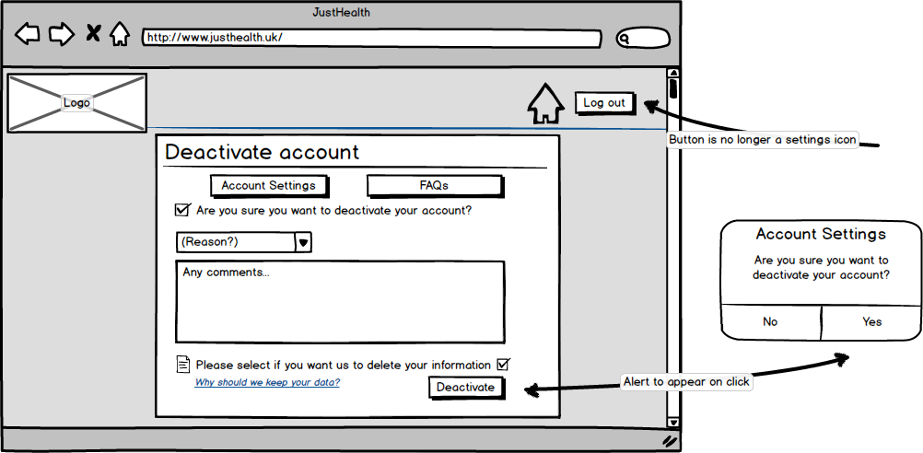Give all pages the same appearance

## webfaq23.7 FAQs

Frequently asked questions will now have a dedicated page, this aims to improve user experience. Each question can be clicked to reveal the answer and navigation to different pages will be improved, linking sections where appropriate.

## websearch23.8 Search

The search page will be improved to give it the same appearance as the other pages. Navigation will also be improved on this page.

# 4.0 Android Design

As a result of feedback post the first release of JustHealth, we have decided the application is in need of re-design. This is to improve the user interaction with the application and to make it more professional.

Each of the pages have been wire-framed again to give us an idea of the new appearance, this will help us to envision what we are working to produce in regards to design. We decided to incorporate more of the standard android themes, change the colour schemes and to ensure that we are maximising the use of the built in android components.

## 4.1 Log in

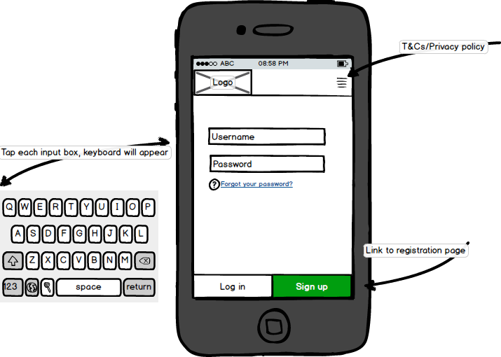

Much of the redesign is in line with our reassessed capabilities, in regards to the android themes. At times we have realised that we simply aren’t able to have the freedom of design that we would like.

## 4.2 Register a user

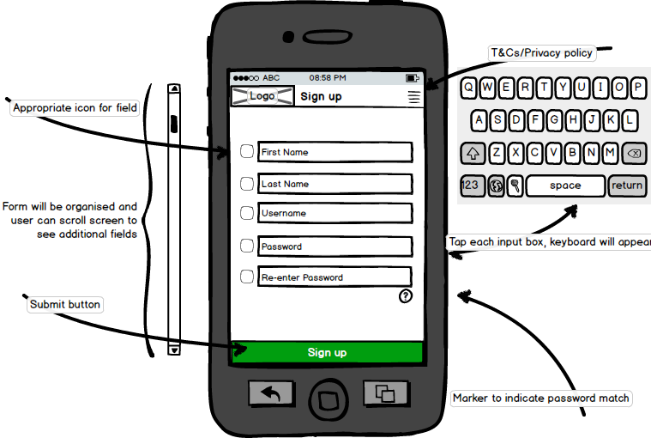

## 4.3 Appointments pages

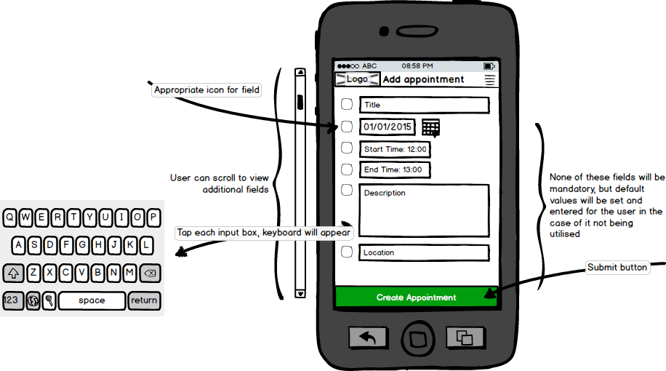Form to add a new appointment

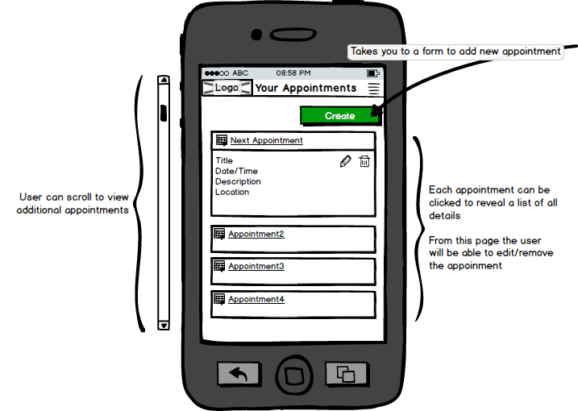List of the user’s current appointments, made to be more user friendly and will have clearer navigation to other pages.

## 4.4 Connections pages

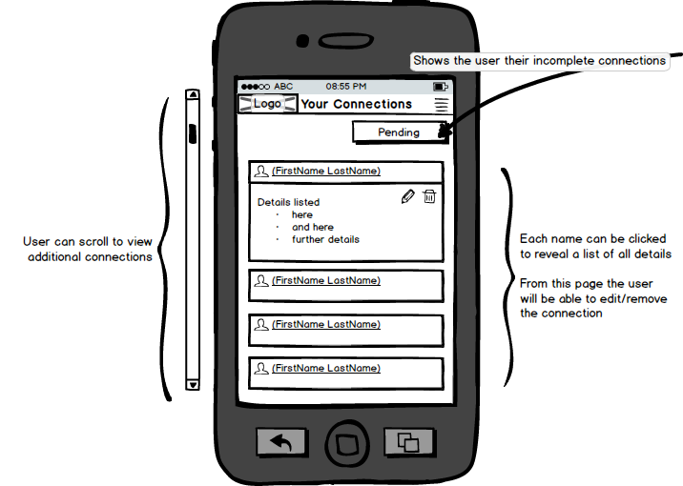Current connections page: Shows basic details with the option to remove each connection.

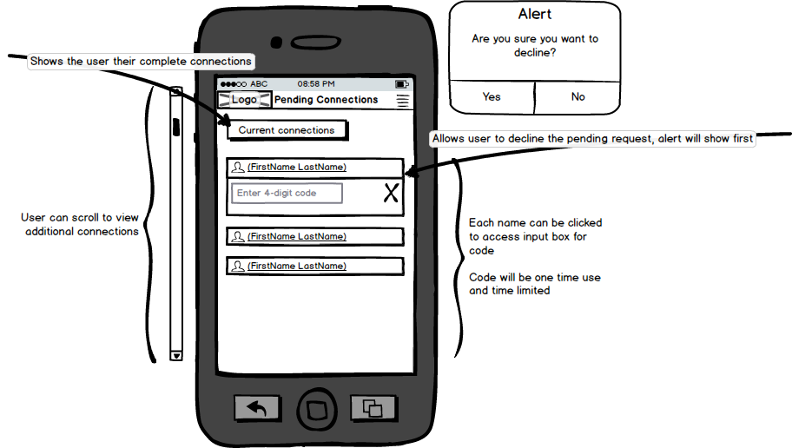Pending connection page: Any pending connections will appear here.

## 4.5 Example Template Page

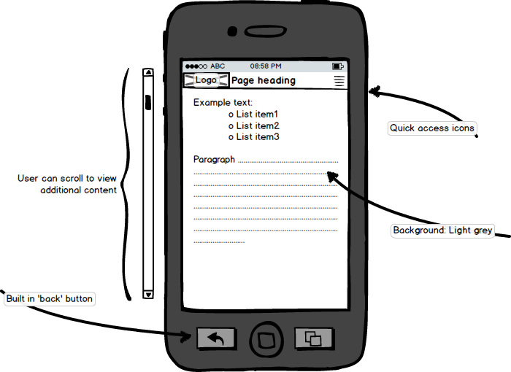Page content will appear on a page within the example template

4.6 Deactivate Account